**month 2025 FPCA**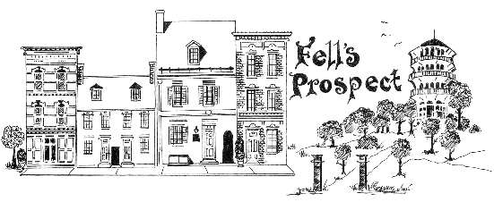

**General Meeting Minutes**

**7:05p: Commence**

There are vacancies in the FPCA board: Vice President; Beautification Chair; Safety Chair; Community Engagement Chair. Interested members are invited to reach out to [President@FellsProspectCommunity.org](mailto:President@FellsProspectCommunity.org) or [Secretary@FellsProspectCommunity.org](mailto:Secretary@FellsProspectCommunity.org)

* Redline project
  + redlinemaryland.com for project updates
  + Request to have agency guest after Ryan detects a decision point is approaching. Estimated 2-4 months out.

Committee updates

* Safety
  + Baltimore/SE are experiencing a recent record low homicide rate, while petty crime and carjackings persist higher.
  + Seeking interest in scheduling a CopWalk date when the weather gets warmer. Please email [Safety@FellsProspectCommunity.org](mailto:Safety@FellsProspectCommunity.org) if you’d like to lead an event.
* Beautification
  + Care-A-Lot grant: No deficient lots are known for eligible mowing services.
  + Dumpster Days are not available for scheduling yet but will be this week.
  + There is an abandoned handicap parking space on Bank St @ Washington St.
  + Community suggestion for branding/signage in places where FPCA conducts clean-ups.
  + Request to probit parking at/during clean-up sites/
  + Secretary requested specific blocks to evaluate café lighting from community members. Need list of names/willing signatories of 50+% of block, in order to move forward with grant funding.

Merger proposal

* FPCA President, UFPIA President: Talks began in 2024 with UFPIA to combine associations. Goals include: Unifying neighborhood voice to city; More consistent momentum in projects; Access to existing UFPIA grant-writing frameworks; Increased visibility. Will meet with the same committee UFPIA has formed to exchange findings and present to both associations.
* Both associations’ boundaries would change.
  + FPCA would return southeast of Chester/Eastern to Canton Community Association;
  + Southwest to Fells Point Residents Associations;
  + Northeast of Pratt & Washington to Butchers Hill Association.
  + CCA, FPRA, BHA are already engaging these areas and annexation plans can move forward. UFPIA would extend existing boundaries east to Patterson Park.
* FPCA and UFPIA boards have already discussed internally and are in favor of moving forward.
* FPCA spoke at UFPIA January General Member Meeting. Received positive feedback but also specific concerns to UFPIA resource dilution.
* President: Request to form a committee of FPCA residents to study and engage benefits and challenges. Need to find solutions to address challenges.
* Community members shared stories of feeling excluded from “Upper Fells” association, despite living in the neighborhood by that name.
* Brian (UFPIA): Suggestion to select a project to share, citing previous efforts of similar kind.
* Community suggestion to share human effort resources.
* Community suggestion of “two associations but one in name.”
* Community suggestion to overlap association meetings quarterly.

Open Discussion:

* Resident spoke about interest in creating dedicated EV charger parking spots.
  + There was a previous discussion which centered around uncertainty with Patterson Pins development, which is now complete.
  + Suggestion about parking inside the park because it is public land.
  + Suggestion to locate on Broadway. UFPIA President remarked that the same discussions had not succeeded internally at UFPIA.

**8:15p: Conclude**