**April 2025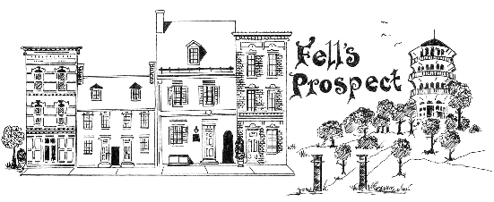 FPCA**

**General Meeting Minutes**

**7:00: Commence**

Mark Parker

* + Discussed his various committee assignments.
  + Received the City budget and has begun the public aspect. Budget must be passed by June 1st.
  + Seeking unified council votes to decrease number of concessions made to Mayor’s office.
  + CharmCityTV is official city channel.
  + Budget Director discussed details about how to potentially lower property taxes.
  + There are some increased fees:
    - Large haulers at city dumps. Currently half of surrounding facilities.
    - Increased ambulance costs within the city.
    - Water/sewer rates. Set by Board of Estimates, not Council.
      * Question about large, delinquent water using properties.
      * Question: After the changes are done, will our rates go down? Answer: presumably yes. The funds collected are not “city revenue” but are in the pool of funds collected through fees. Correcting delinquent billing may not be savings we realize for decades.
      * Question: What’s with the lack of coordination between BGE and DPW water street work. Answer: There has been a 10 year effort to create a “One dig policy”. BGE has not cooperated.
      * Question: General Services has a blanket permit. Why aren’t they held to the same standards as contractors?
      * Question: Is the pool going to be open this year? Answer: Yes. Last year, infrastructure was installed before opening season. This Fall, additional improvements will be added.
* Mae Hanszlik (DOT)
  + Monet is our Community Liaison; send her your neighborhood concerns.
  + Washington St. Bikeway. Sinclair Lane to Aliceanna 2.1 miles, west side of street. Improving ADA, pedestrian facilities and bus facilities, intersection improvements. 2017 Bike Master Plan. Speeding complaints have encouraged this project. Goal to connect end points and in-between for biking, scooting, walking, strollers.
  + Most of the efforts were public in the 4 community engagement meetings between 2001-2023. Parking was a top feedback topic. Both lanes of parking are being kept.
  + Questions:
    - Traffic calming: Will there be speed enforcement mechanisms on Washington and surface streets that take up additional traffic. How do we address traffic calming on Chester st. Answer: “Vision Zero” “near miss survey” is available now; <https://streetsofbaltimore.com/visionzero> High Injury Network to study severe crashes and make improvements.
    - How are surface streets going to be prevented from taking additional diversion traffic? Answer Washington volume can be handled by single lane.
    - Ambulances: working with Hopkins to adjust routing.
    - Traffic calming is implemented to accommodate fire trucks turning at intersections.
    - Recent traffic signal timing has helped. It seems timed for 25MPH. Concerned about flexpost being the low-quality way to reduce budget constraints.
      * Precast concrete posts are being used.
    - Several intersections don’t have crossing signals. Will they be addressed? Answer: Believed to be “yes.” Goal is to finish next summer.
    - Bikemore: planning started in 2015. 73% of respondents were in favor of bike lanes, 77% in favor or bike master plan. Road diets recommended for roads < 10,000 cars/day. Washington is <5,000. Fire/ambulance equipment is not affected. 41% reduction on Potomac bikeway.
    - Is a 9ft bi-directional bikelane an option in order for room for cars to get around. Answer: no.
  + Safety: Do not have trend analysis yet.
  + CE: Goals: Newsletter delivery; Looking to grow General Meeting attendance. Newsletter went from 55% to 65% of FPCA boundaries delivered.
  + Beautification: April 5th filled community dumpster and cleanup event. More than 20 volunteers. Next cleanup event on May 31st. Hoping to make monthly, seeking volunteers to join. Neighborhood walk event to find additional areas that need attention. Workshops to beautify stoops, sidewalks.
  + Merger update: Met externally with UFPIA and internally. Looking to “start dating” with UFPIA Board and MC, then expand to broader cmty. As talks continue, we will be continuing our own objectives.
  + Cleanup this Saturday at Louanne Galary at 10am.

**8:06 Adjourn**